Now jo basic jupyter notebook hai wo hum **Skill network lab** platform pa use kreinga which is platorm by IBM, But how to access it ? toh uskay liya jo apkay course may hands-on wala portion hai usko use krtay huye you can access the **skill network lab.**

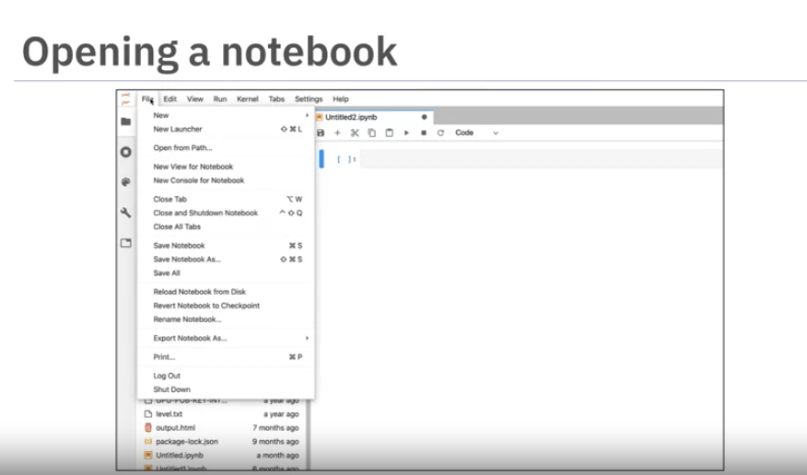

Click the plus button on the top bar, then select the notebook below:

Click on any notebook above to work with

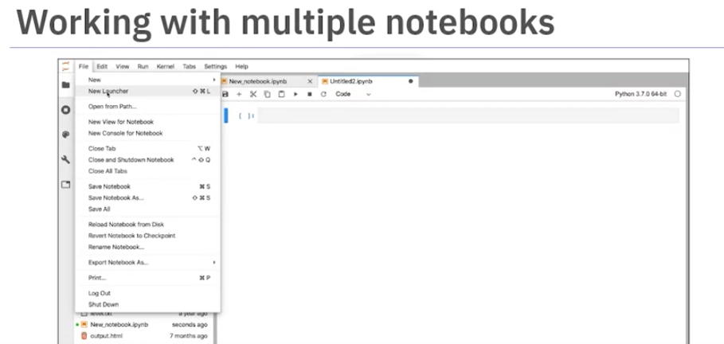

You can also launch new notebook

Now if you want to present your notebook with some theory as well so you can write that explanation/theory using Markdowns within Code cells.

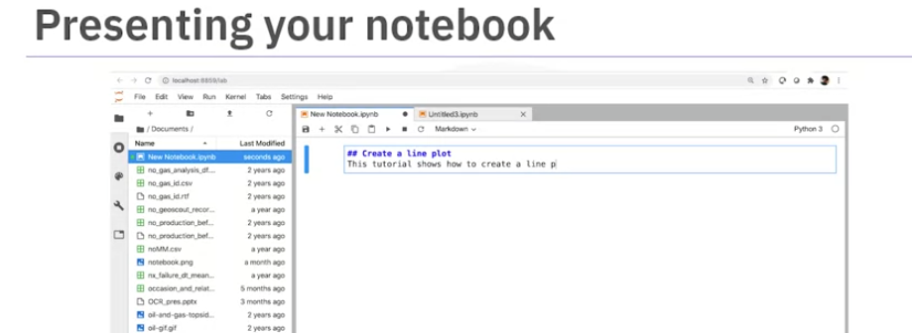

When you will shut down the session you will that no kernal at the top of your notebook, which means notebook is shutdown.

